**CSF-510 Application Development**

**Instructions for Project Proposal**

**Due Date: 10th November 2021**

**Marks: 5 marks**

Towards the end of the semester, you are required to submit a Project which carries **20 marks**. The objective of this course project is to build a **web-based application** to solve any real world problem. You can work with various Python libraries taught in the class.

**Project Ideas**

Below are some ideas that you can choose to work on:

1. **Dashboards**:

Web-based dashboards can be built using Python Flask library to visualize and analyze the dataset of your choice.

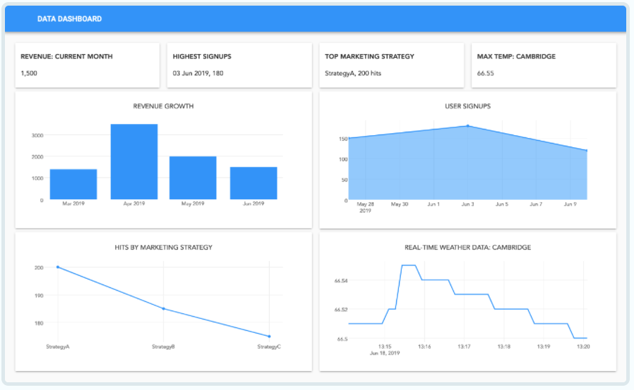

1. **Text Processing tool:**

Text processing is the way to extract valuable insights from the given piece of text. You can compute word count, visualize word frequencies, extract keywords e.t.c

1. **Search Engine**

You can use Web APIs from various websites such as Youtube, Coursera, Udemy, Open weather, stock trading (<https://finnhub.io/>) and build a search engine over it.

**Project Proposal**

Choose any interesting problem and submit a 1-2 page project proposal. The proposal should specify the following details:

1. **List of Team members**

The maximum number of team members allowed for this course project is **2**. 3 members are allowed only if the project is big enough.

1. **Project Description**: Describe the project idea you will be working on.
2. **Dataset/Web APIs**: Specify the dataset or web API you will be using in your project.
3. **Python Libraries**: Mention the list of python libraries you are planning to use in your project.
4. **Features:** Discuss the features of your web application.

**Final Project Deliverables: 15 marks**

By the end of this semester, you are required to present your web application in class. The deliverables of this project include:

* A well-documented code
* Flask based Web Application